Safeguarding Children Foundation

Pre-course workbook

Reflective portfolio

Your name | A.N.Other
Date completing portfolio | 1st September 2020
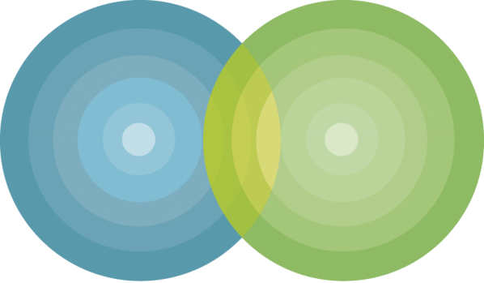

introduction
Welcome to the Bristol City Council Safeguarding Children Foundation course. We are looking forward to seeing you on the day of your training.
You should already have completed the Learning Pool elearning course – if you haven’t yet completed this training please do so now. If you have any problems contact the Learning & Development team.
This workbook is to be completed prior to the course. You’ll use it to help you contribute to the groupwork. You will need between half an hour and an hour to complete the exercises. The workbook is a mandatory element and you may be asked to share your completed workbook with the Learning & Development team.
The training is provided by dialogue, a safeguarding training and consultancy company. We support organisations across the country to develop a strong and effective focus on improving the lives of young people. Our trainers are experts in the field, but most of all really care about young people and about building your skills and confidence so that you take the right action to keeping young people safe.

the trainer
Rachael Courage is a qualified social worker. As well as delivering training she is a part-time child protection conference chair, meaning she works with the most vulnerable children and their families every week, listening to their worries, assessing the risk to their children and putting together plans with staff from a wide range of organisations to ensure these children are able to live safely at home.

the course
The training course will take place on the Zoom platform. There’s information on how use Zoom on the course page, together with a link to launch the course.

Pre-course reading
As well as the e-learning element we would like you to learn about the Keeping Bristol Safe Partnership and the Keeping Children Safe (KCS) Business Delivery Group. These important groups provide a supportive framework for all parts of Bristol City Council. There is up-to-date information on the Bristol City Council website.
To help you explore the website pages we have listed them below and have written eight questions for you to find.
- Keeping Bristol Safe Partnership (KBSP)
  - https://bristolsafeguarding.org/about-us/
  - https://bristolsafeguarding.org/about-us/who-we-are/
  - https://bristolsafeguarding.org/about-us/what-we-do/
- Keeping Children Safe (KCS)
  - https://bristolsafeguarding.org/children/about-kcs/
  - https://bristolsafeguarding.org/children/i-am-a-professional/
- Domestic abuse and families
  - https://bristolsafeguarding.org/policies-and-guidance/domestic-abuse-and-families/
- Think Family microsite
  - https://thinkfamily.bristolsafeguarding.org/

Here are the questions:

1. Who are the three statutory partners represented on the KBSP?
2. What is the main role of the KBSP with regards to children?
3. What three key activities does safeguarding and promoting the welfare of children involve?
4. What are the three key priorities of the KBSP?
5. Within the Think Family approach, which key issues for parents are shown to have the most significant negative impact for children?
6. Who does the Keeping Children Safe website say you should contact if your organisation is worried about a child?
7. What is a MARAC?
8. What is the purpose of a Child Safeguarding Practice Review?

Values & Attitudes
Please be aware this exercise includes information that may be upsetting. If you are affected by the exercises please speak to your supervisor or contact the Employee Assistance Programme (intranet link) for confidential counselling and advice.
The exercise on the course will start with your views about the risk children may be at. We want you to read each of the following mini-scenarios and think about whether you think this is abuse, using the categories you learned about on the elearning course.
What are you worried about? What impact will this have on the child?
Complete the questions before the day – you’ll be asked on the course to work in small groups and think about risk to children and young people: who we are, our experiences and the way we think all contribute to the way we see risk that children may be at.

- You visit Sarah at her home. She is Mum to 6 month old Alfie, 2 year old Chantelle and 4 year old Joshua. She tells you that she does not wish to stay in this world. She says that she is hearing voices and that nobody can look after her children like she does and she will not leave them behind.

Is this abuse?
If so, which category of abuse?
What are you worried about?
If nothing changes, what impact will this have on the child?

- Three month old Sasha has a small bruise, the size of a 5 pence coin, just below their ear. Dad says that Sasha fell off the changing table and bumped their head on a toy on the floor.

Is this abuse?
If so, which category of abuse?
What are you worried about?
If nothing changes, what impact will this have on the child?
- Danika is 10 years old. She tries to spend as much time with adults as is possible. She always wants to speak to you and tell you about her day, although sometimes she makes stories up about her life – telling staff that she has been on trips out, or family events that have not happened. You are helping her with a task when she tells you that she is useless, and will never get anything right, her Mum always tells her not to even bother trying.

You speak to Mum about your concerns and Mum tells you that Danika “was born stupid, there is no point trying anything with that girl, she can’t do anything right and she will probably get herself pregnant and waste her life away.” When you ask Mum what Danika is good at her response is “causing trouble, I wish she had never been born”.

Is this abuse?
If so, which category of abuse?
What are you worried about?
If nothing changes, what impact will this have on the child?
- Chantelle is 15 years old. Until recently her best friend was Becky, who was also 15 and dual heritage. Chantelle has not been spending as much time with Becky, and she started to talk about a new group of friends that she met online. Becky comes to you; she is really upset because she overheard Chantelle telling a group of other girls that Becky wasn’t her friend because she isn’t “English” enough. Becky thinks that Chantelle has a tattoo of the number 88 and a skull. Chantelle has also talked about going to a meeting with her new friends at the weekend.

Is this abuse?
If so, which category of abuse?
What are you worried about?
If nothing changes, what impact will this have on the child?

your department
Through the course you’ll have explored what to look for and how to identify signs of abuse or neglect. You will think about how to respond to a young person or family member. We want you to be confident that you know what to look for and know what to do.
Thinking about your role in your team, can you answer the following questions. If you’re not sure, check it out before the course:
- Who is the Safeguarding Lead?

- Who do you talk to if the Lead is not available?

- How and where do you record concerns?

Thank you for registering for the Safeguarding Children Foundation course. After the course the Learning & Development team will confirm your attendance and then send you your certificate.
We’re looking forward to seeing you on the day.

Rachael Courage John Woodhouse
trainer managing director

