**The Karpman Drama Triangle**

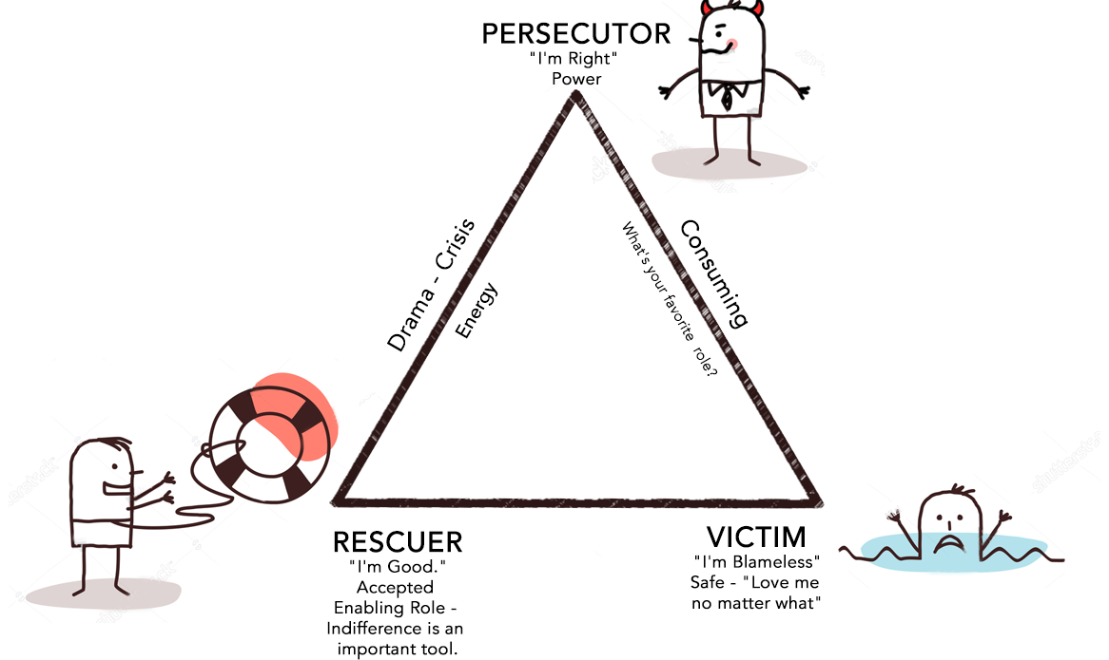

The basic concept underpinning the Karpman Drama Triangle is the connection between responsibility and power, and their relationship to boundaries.

The Karpman Drama Triangle was originally conceived by Steven Karpman and was used to plot the interplay and behavioural “moves” between two or more people.   Karpman’s original premise was based on the Transactional Analysis model as proposed by Eric Berne in the 50’s.  Berne’s hypothesis is that people form a “Script” which is essentially an individual’s concept or belief about who they are, what the World is like, how they relate to the World, how the World relates to them, and how others treat them.   Psychologists theorise that an individual forms their Script by the time they are four or five.   A Script is based on what an individual is told, what they experience, and how they interpret these external stimuli from their own internal frame of reference.

How does the Karpman Drama Triangle work?

Whilst it was originally devised as a therapeutic tool, it is also a communications device and plots the moves of a series of transactions between people. It is in this context that we use it in coaching, although its use will also give us insights into our client’s belief system and behaviour.

Essentially Karpman devised a simple formula which plots the moves of a “Game”.

It is this;  
**con + hook = series of complimentary transactions → switch → pay off**

The moves are as follows.

Someone – usually the Victim – presents a con: “Can you help me?”

The particular con matches the specific hook of the person to whom it is directed, who will usually be a Rescuer, however some Victims play to and “hook” a Persecutor.

The other party – (let’s imagine it is a Rescuer) responds by saying “Yes, of course I can help you!”

[Note. If the con does not match, the prospective Rescuer/Persecutor usually will not be “pulled in” or “hooked”, and the Victim will wander off to find someone else to play the game. Alternately the Victim may try to initiate another Game, this time from the position of being a Persecutor, e.g. “You’re a rubbish manager” or perhaps ”Are you registered?” or even “Have you actually had any supervision training?”

Once the Game begins, a series of complementary transactions will continue as long as it suits both parties.    In some instances this series of complementary transactions can go on indefinitely and may take the form of a life long friendship or marriage as both parties are content to stay in the Game without going for the pay off.    However more often than not, one party becomes discontented or unhappy, for whatever reason, and pulls the Switch ………….Oh dear.   Things then usually fall apart pretty quickly, and the players whiz round the Triangle like players on a snakes and ladders board!

The Rescuer usually at this point becomes the Victim, and the Victim often becomes the Persecutor,    The Game is over and both retire with that “Old Familiar Feeling” to nurse their wounds.     Game Set and Script!

It can be observed that the Karpman Drama Triangle works at both the social level – that is observable behaviour, and at the internal dynamic level –  that is what a player feels inside. It is therefore quite possible to feel a Victim and be seen by others as a Persecutor, or present as a Victim but in reality be a Persecutor.

## Definitions of the Roles.

A “**Rescuer**” is someone who often does not own their own vulnerability and seeks instead to “rescue” those whom they see as vulnerable.    The traits of a Rescuer is that they often do more than 50% of the work, they may offer “help” unasked, rather than find out if and how the other person wants to be supported, and what the Rescuer agrees to do may in actual fact not be what they really want to do.  This means that the Rescuer may then often end up feeling “hard done by” or resentful, used or unappreciated in some way.     The Rescuer does not take responsibility for themselves, but rather takes responsibility for the perceived Victim whom they rescue.

The Rescuer will always end up feeling the Victim, but sometimes may be perceived by others who are on the outside looking in, as being the Persecutor.

A “**Victim**” is some one who usually feels overwhelmed by their own sense of vulnerability, inadequacy or powerlessness, and does not take responsibility for themselves or their own power, and therefore looks for a Rescuer to take care of them.     At some point the Victim may feel let down by their Rescuer, or perhaps overwhelmed or even persecuted by them.    At this stage the Victim will move to the Persecutor position, and persecute their erstwhile Rescuer.    They may even enlist another Rescuer to persecute the previous Rescuer.     However, the Victim will still experience themselves internally as being the Victim.

The position of “**Persecutor**” is synonymous with being unaware of one’s own power and therefore discounting it.    Either way the power used is negative and often destructive.  Any player in the “game” may at any time be experienced as the Persecutor by the other player/players.   However their own internal perception may be that they are being persecuted, and that they are the Victim.   There of course are instances in which the Persecutor is knowingly and maliciously persecuting the other person.  If this is the case, then strictly speaking the Persecutor is no longer playing a “Game “ in the TA sense of the word, as the Persecutor is operating from a place of conscious awareness; it could then be argued that they are in fact employing a strategy.

Each of the positions is taken up as a result of an issue being discounted or disowned.

* The **Rescuer** needs to take responsibility for him/herself, connect with their power and acknowledge their vulnerability.
* The **Victim** needs to own their vulnerability and take responsibility for themselves and also recognise that they have power and are able to use it appropriately.
* The **Persecutor**needs initially to own their power, rather than be afraid of it or use it covertly.