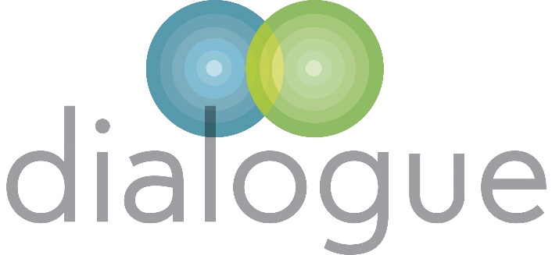

RI Network - 19th March 2024
at The Kenn Centre, Exeter

Understanding the Residential Sector project (afternoon session)

Commissioners in attendance:
Lucy Clapp- South Gloucestershire
Julie Breeze - Somerset
John Branchflower - QA (Interim) Plymouth.

How do we improve the understanding of the sector?
Came out of the conversations RE: inflationary increase. Relationships in SW built through C19 and wanting to work together.
What is getting in the way?
Who are the problem? (If appropriate)
Pairs discussions - what is the problem?

Feedback:
- Senior management change in the LA.
- Commissioners caught between relational commissioning and a corporate view/structure/process.
- Variation in LA approaches and culture.
- Overriding of existing arrangements.
- ADCS
- Elected members.
- Local relationships need nourishing.
- Inherent tensions with multi LA collaborations.
- Everyone understanding the role of the commissioner.
- Commissioners in a difficult position/level of influence in their organisation.
- Commissioner as “messenger/go between” and trying to maintain relationships.
- Sometimes decision made with a real lack of understanding of individual need.
- Fees.
- Needs/risk of child has significant change. Immediate support in place/panel refused changes. Where does this leave the provider?
- SW referrals - what models are to be used. Sometimes disjointed approach in relation to other services.
- Not understanding local provision available.
- Training for SW in respect of referrals.
- Variations of working within similar parameters. E.g. given of educational psychologist variation.
- Approach to spot purchasing/risks inherent within that.
- Real lack of understanding of sufficiency across the services. Defaulting to a really poor narrative. Need to shift the narrative. Nuancing related to profit and size of organisation is not generally there.
- Intentional/unintentional outcome of LA stance in terms of the development of the independent market. Damage to reinvestment. Overleveraging becomes more of a risk factor for the bigger organisation.
- Longer term organisation viability.
- Baseline - what are the drivers in society which ae causing the increase in need? Legacy issues.
- Constant need to look at the context.
- Need to look at the financial climate and within this – how do we get more creative? We know some of the issues coming our way, societal, political and post pandemic.

WHAT WOULD GOOD LOOK LIKE ? WHAT ARE WE TRYING TO ACHIEVE AS A GROUP ?
- How do we change/influence/nuance for ADCS/elected members.
- Question quite hard to answer - consistency of approach, issues which will escalate. Provision to match need and want need to go down. What are the drivers of need?
- Senior leaders have a clear understanding of what placing services look like in the future; able to support preventative measures through investment.
- Sector can clearly explain costs. Senior leaders understand those costs. If it does not happen the cost to society will look like this. Cost of care models?
- Need for understanding that there is a place for residential care.
- Need to be creative. Role of foster carers. Appropriacy of foster care and residential? Issue related to adoption breakdowns.
- Shared common visions - at this level. Perception outside of this group is different.
- Understanding of issues within the context of regs and standards. E.g. staffing ratios.
- Clarity of understanding of cost to need. Who is the decision maker re. placing/cost? Their understanding?
- Julie - also caught between a range of people who do not understand/picking up other messages.
- Lucy - residential feels alienated within the market - use of language does not help.
- Would it help to put together face to face visits – be useful.
- Trust and its’ role -QA/monitoring. Value needs investment – John B.
- Need for an ongoing feedback mechanism/QA to give assurance. Feedback – and its’ role.

ACTION:- SET UP SCO, CABINET LEADS WITH PORTFOLIO, CORPORATE PARENTING ROLE, DCS, ADCS, CHIEF EXEC, CFO- visit opportunities - JOINT PIECE OF WORK.
JW to put together a proposal – series of facilitated visits and an event. What is the purpose of the event day? Improve understanding of why services cost what they do. Timing TBC?

ACTION:- OVERVIEW WHICH GIVES A SLIGHTLY DIFFERENT NARRATIVE. Individual approach (Julie/ADCS).

ACTION:- Lucy – look to equity in terms of contact and inclusion of small/medium providers.

ACTION:- Standing agenda item on RI/commissioner meeting to take forward in terms of planning.

